Skillet Name – Deactivate PANOS Licenses Offline

# 

# 

# Brief Description

This skillet provides a workflow to deactivate PANOS licenses when the Firewall could not connect to Internet.

# How to use

* Login into Panhandler, and import Skillets

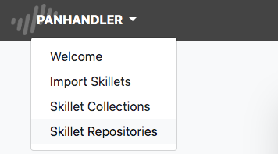

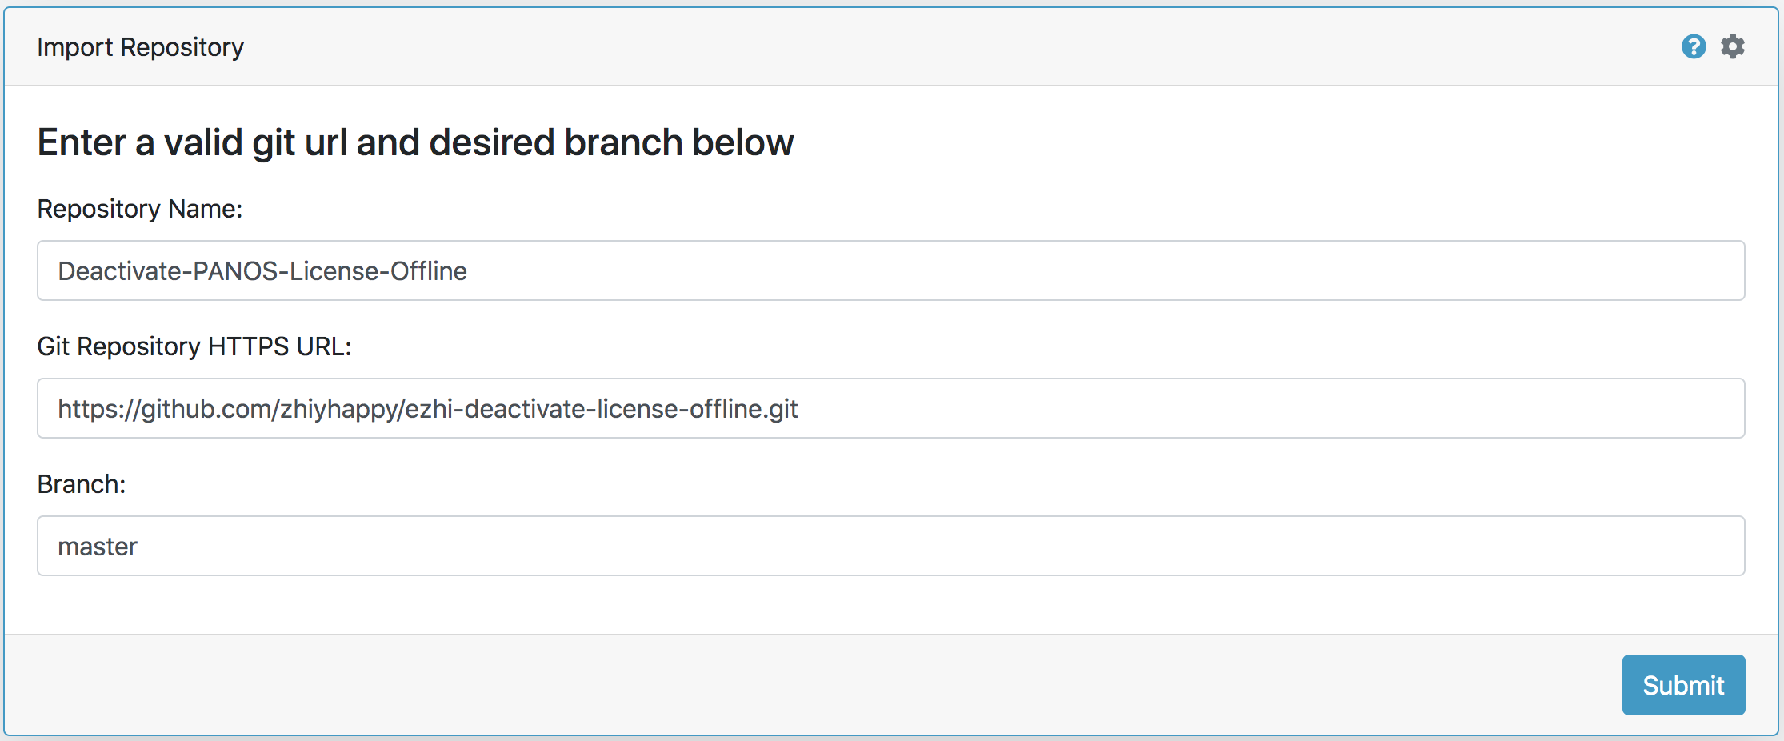

* Get into Skillet Collections and then select skillet: ***ezhi-deactivate-license-offline***, click Go, then you will get 1workflow and 6 separate steps shown on the page.

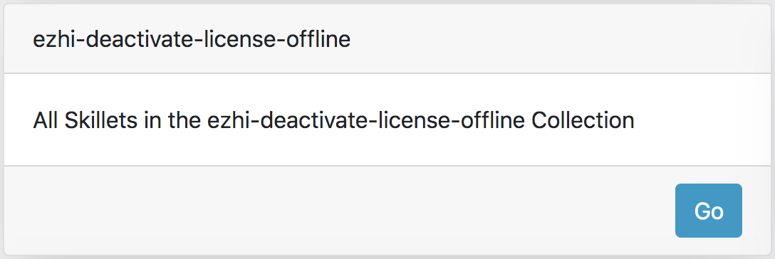

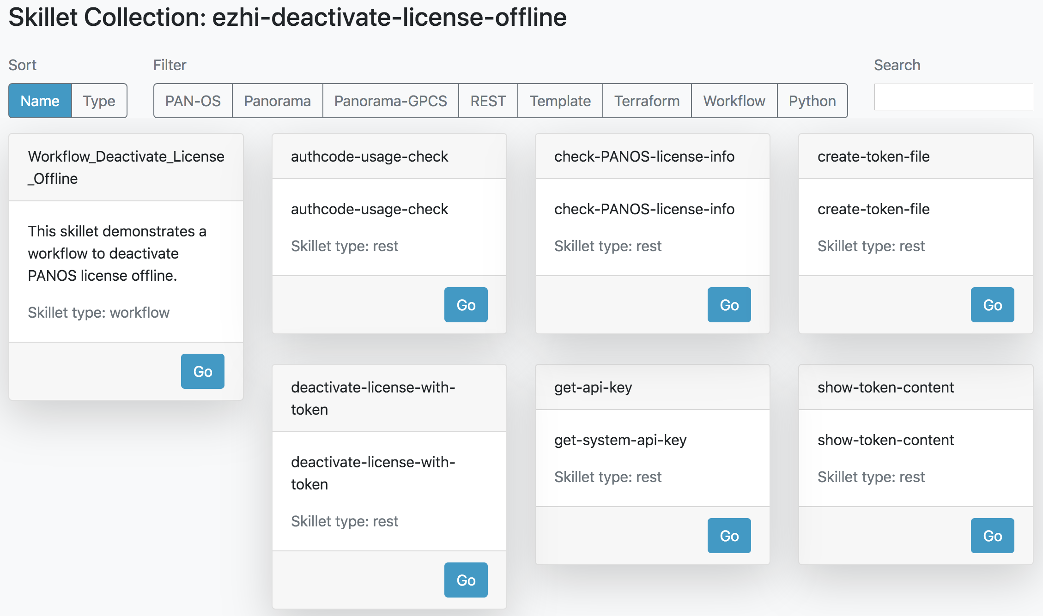

* Select ***Workflow_Deactivate_License_Offline***, click Go, then follow the guide to finish all the steps.

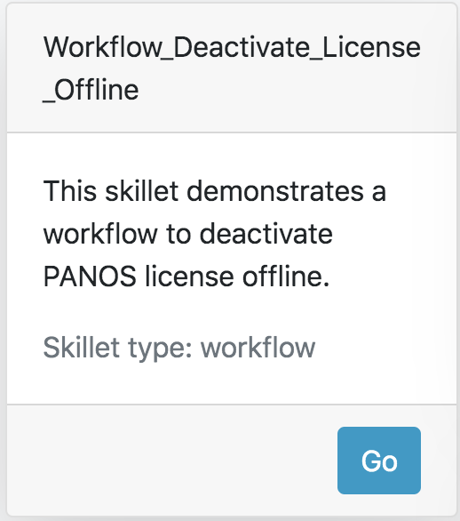

* Click Summit to start the workflow.

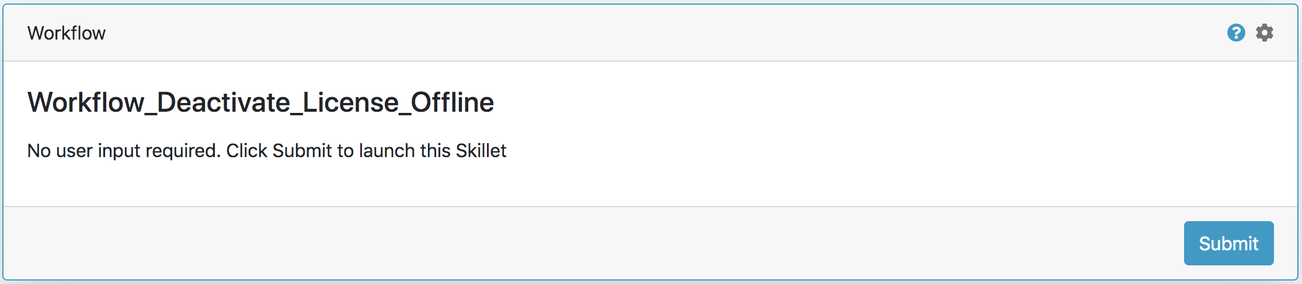

* Input the Firewall IP address, username and password, then submit to generate PANOS API key.

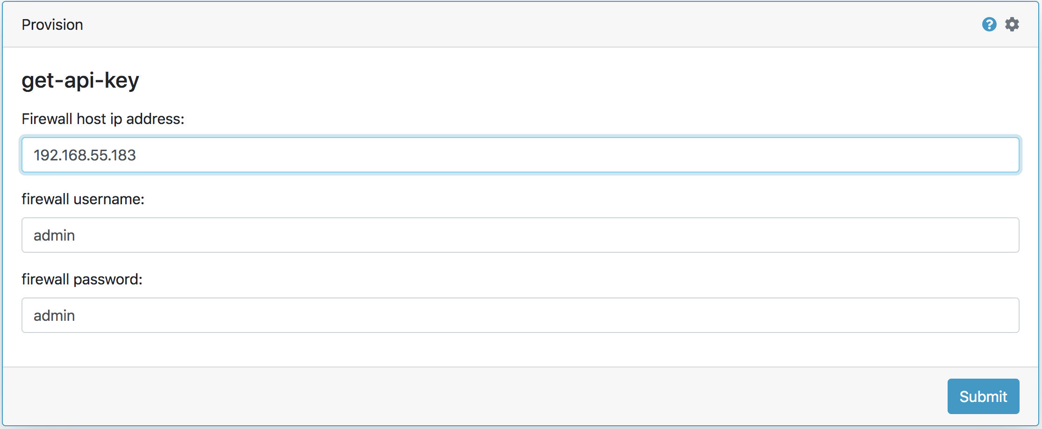

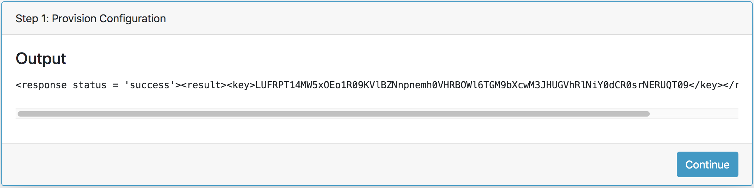

* Click Continue – Using API call to create a deactivation token file in the PANOS device. You don’t need to input the host IP address and API key, which will be transferred from the previous skillet automatically, then you will get the output with deactivation token file name.

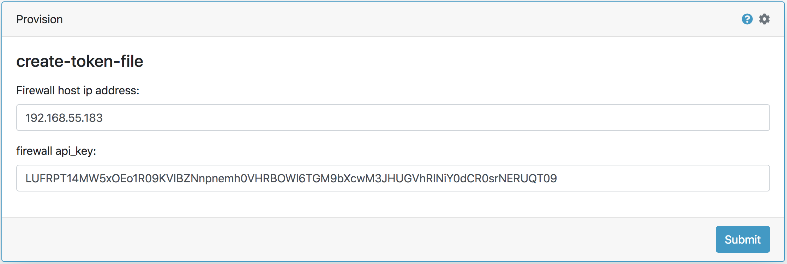

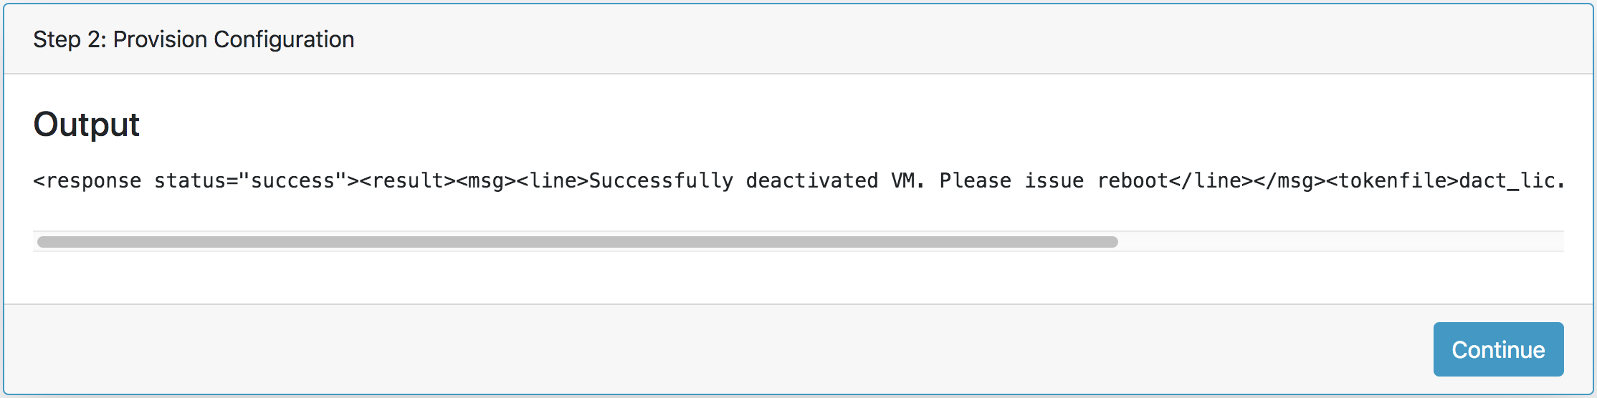

* Click Continue – With the Firewall hist IP address, licensing API key, as well as the token file name, you may get the detail token file content via API call. Here you don’t need to input the parameters, which will be transferred from the previous skillet automatically. After submitting, you will get the detail token content information.

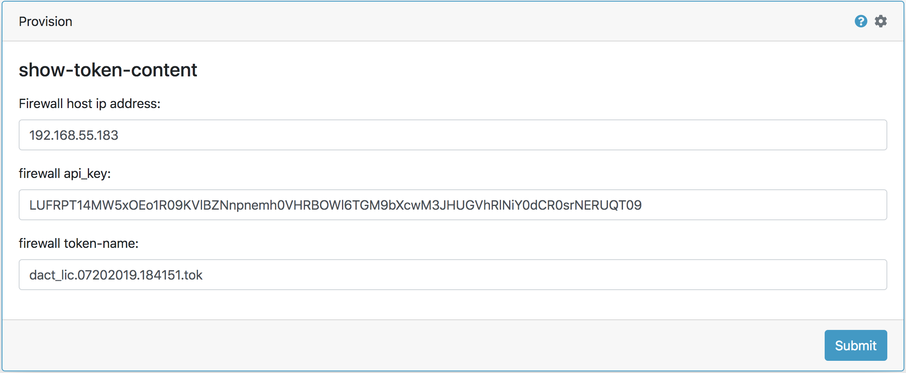

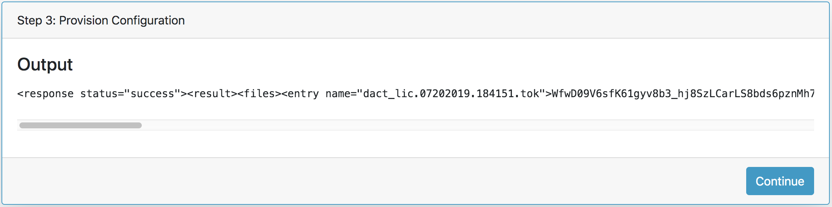

* Click Continue – In this step, you will use your Licensing API key and the token content to deactivate all licenses from the licensing server. Here you don’t need to input any parameters, which will be transferred from the previous skillet automatically. After submitting, you will get the output with result.

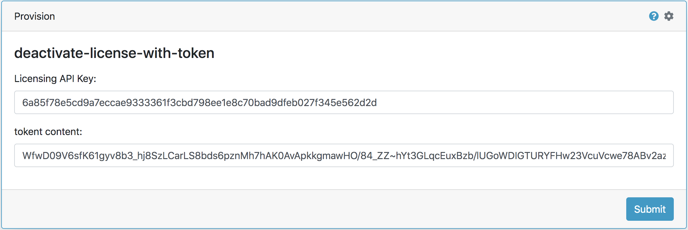

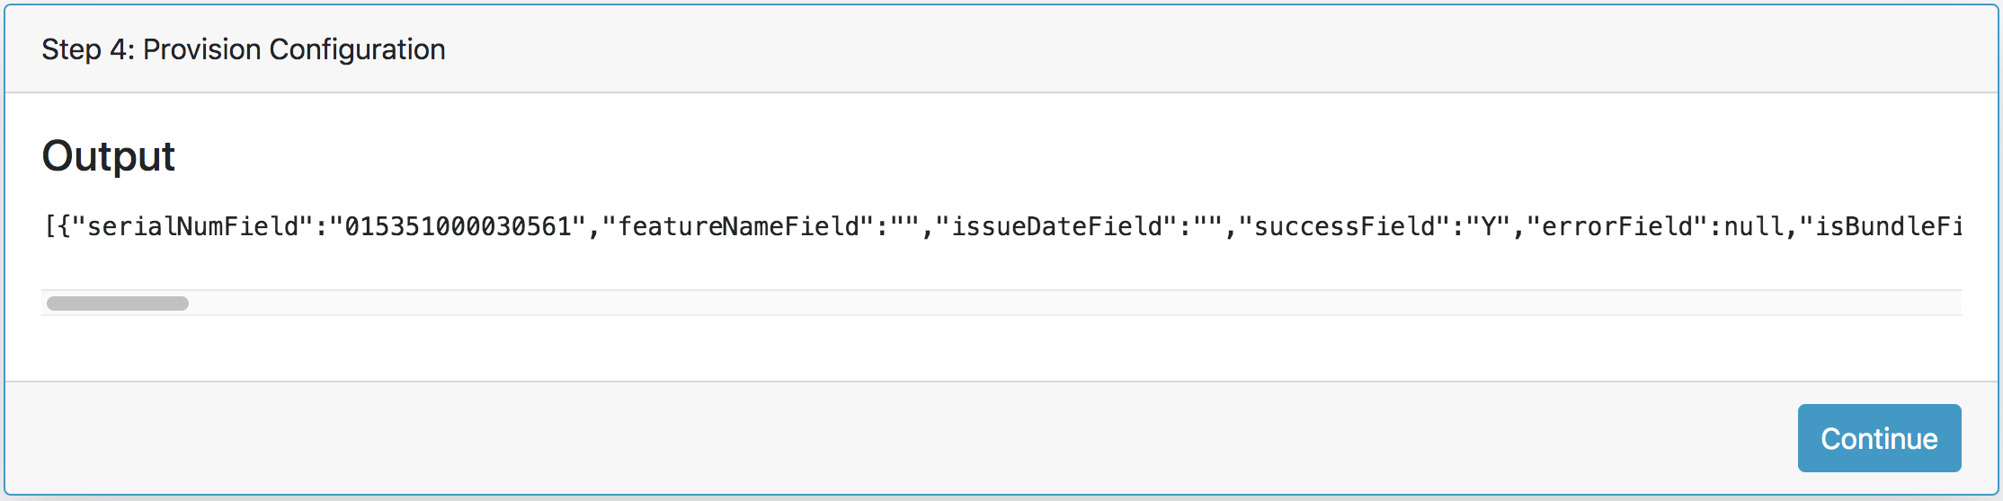

* Click Continue – In this step, you will get the firewall license information via API call, here you may find all the licenses have been removed from the PANOS device.

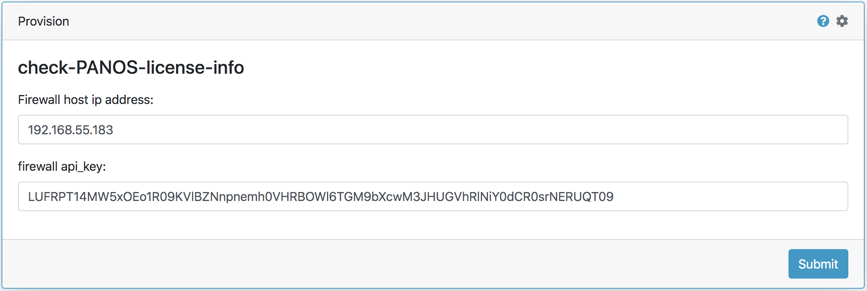

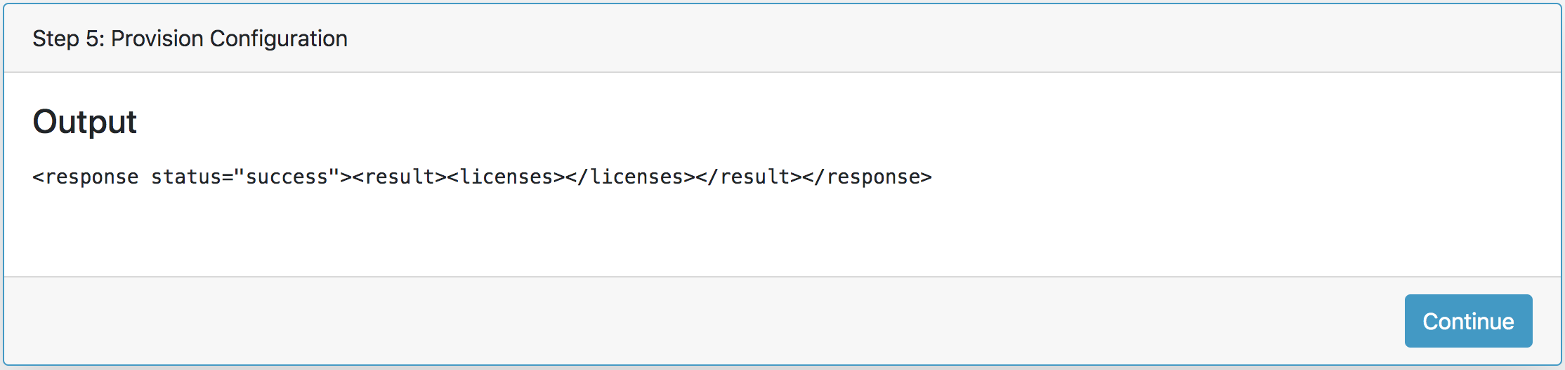

* Click Step 6 – Using the Licensing API and Auth-code to check the Auth-code usage.

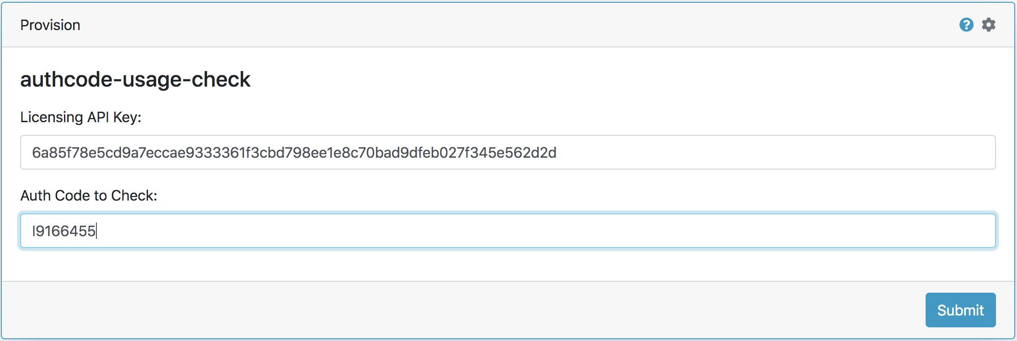

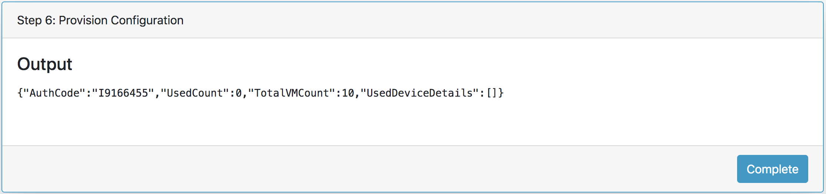

# Github Repository

# https://github.com/zhiyhappy/ezhi-deactivate-license-offline.git

# Requirements

* Panhandler
* PAN-OS 8.1 or greater